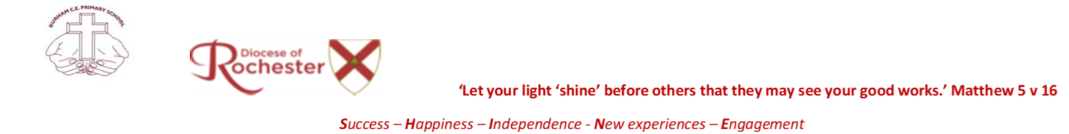

French Curriculum Overview (Years 3 – 6)
 | Term 1 | Term 2 | Term 3 | Term 4 | Term 5 | Term 6
Year 3 | The Basics 1  Hello! (Song)  How Are You?  What is Your Name?  How Old Are You?  My Family  My Fantastic Family (Story) | The Basics 2  The Days of the Week (Song)  Colours  Let's Count up to 20  Countries  I Like...  Nicolas the Monster (Song) | The Basics 3  Head, Shoulders, Knees and Feet  Parts of the Body  Let's Count up to 31  Clothes  Months  Geneviève's Birthday (Story) | Animals  On the Farm (Song)  Pets  What's Your Dog Like?  Where is the Cat?  Where is the Elephant?  Henri Looks for His Mother (Story) | Food  Food (Song)  I Like to Eat...  What Are You Eating?  Cutlery  Ingredients  French Toast (Story) | At School  How do You go to School? (Song)  Rooms  In Your Pencil Case  What Time Is It?  Subjects  The Magic Bag (Story)
Year 4 | Playtime  The Farmer in His Meadow (Song)  Simon Says...  I Play...  In the Playground  What Do You Like to Play?  Luc the Dreamer (Story) | My Home  Where Do You Live?  Your Home  Your Bedroom  The Kitchen  Daily Routine  Garon the Giant (Story) | My Town  How Much Does it Cost? (Song)  In Your Town  Where is...?  Shops  At the Shop  Éric Goes Shopping (Story) | Describing People  What Are You Like?  Hair  We're All Different (Song)  The Fairy and the Pirate  I'm Wearing...  The Sad Frog (Story) | The Body  My Face  What Are You Doing? (Songs)  It Hurts  Fairy Tales  Where Do They Live?  Little Red Riding Hood (Story) | Sport  Sports (Song)  What Sport Do You Like Doing?  At the Stadium  Wimbledon  Can You...?  A Tennis Match (Story)
Year 5 | On Holiday  Where Are You Going on Holiday? (Song)  Where Are You Staying?  At the Zoo  At the Beach  At the Theme Park  The Theme Park (Story) | Eating Out  I'm Ordering a Drink (Song)  At the Ice Cream Shop  At the Market  At the Restaurant  I'll Have...  A Fly in the Orange Juice (Story) | Hobbies  My Hobbies (Song)  Music  Musical Instruments  The Weekend  Films  Étienne's New Friend (Story) | A School Trip  The Wheels on the Bus  On the Way  Through the Window  At the Museum  In the Countryside  A Trip to the Museum (Story) | Seasons  The Seasons (Song)  Spring and Summer  Autumn and Winter  The Date  Arts and Crafts  Make a Chinese Lantern (Story) | The Environment  The Weather (Song)  The Pond  The Garden  In the Garden  Rubbish  Problems in the Pond (Story)
Year 6 | Actions  I'm Looking for the Pirate (Song)  Actions  In the Cupboard  More Actions  Treasure Hunt  A Treasure Hunt (Story) | In France  On the Bridge of Avignon (Song)  Where in France?  In Paris  They speak French  French Food  Croque-Monsieur (Story) | Family  My Family (Song)  Describe Your Family  Household Tasks  A Family Weekend  My Birthday Party  Cinderella (Story) | A Weekend with Friends  What Would You Like to Do?  Would You like... ? (Song)  Sleepover  The Midnight Feast  Are You Going to Go to the Cinema?  The Sleepover (Story) | The Future  I'm Going... (Song)  This Weekend  Tomorrow  Comparisons  I am...  The Three Billy Goats Gruff (Story) | Jobs  I Want to be an astronaut  Jobs  Workplaces  The Space Station  At the Fire Station  Paul's 'Quiet' Day (Story)

