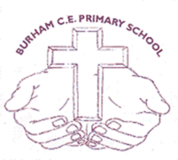
Year 1 Curriculum Overview
 | Term 1 | Term 2 | Term 3 | Term 4 | Term 5 | Term 6
Phonics | 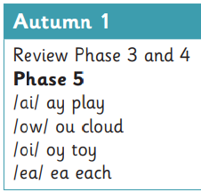  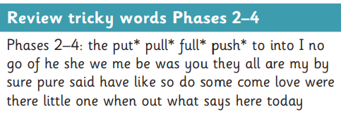 | 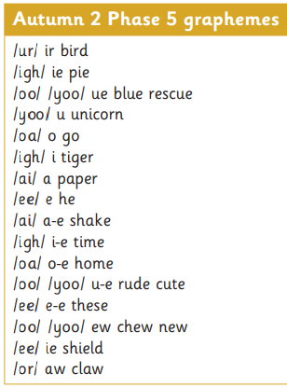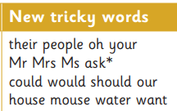 | 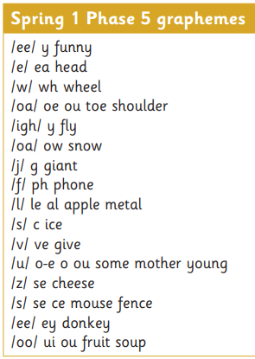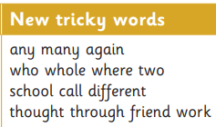 | 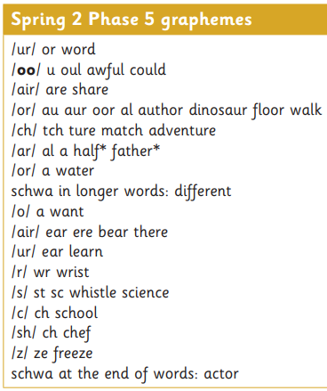  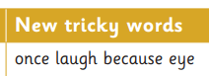 | Summer 1: Phonics screening check review – no GPCs or tricky words | 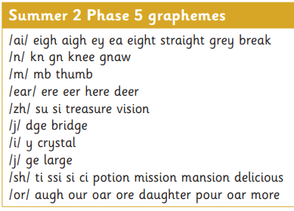  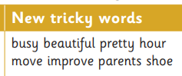
English Book Focus  NC objectives covered throughout*  Role play, debate and immersive experiences woven throughout. | Free write (What did you do over Summer?)  Harry and the Dinosaurs go to school – Ian Whybrow  Seasons come, seasons go Tree- Patricia Hegarty  We’re going on a bear hunt – Micheal Rosen  It was a cold dark night – Tim Hopgood | Free write (The magic Toy)  Fireworks poetry (senses)  Paddington – Michael Bond  Lost in the Toy museum  Polar express – Chris Van Allsburg | Free write (What did you do over Christmas?)  The day the crayons came home – Drew Daywalt  Wild and Free: A book about animals in danger – Mick Manning & Brita Gransrom | Free write (Adventure story)  Grandads Island – Benji Davies  My first Heros: Great Explorers – Campbell | Free write (What did you do over Easter?)  Easter poetry  Goldilocks and just the one bear – Leigh Hodgkinson  Beegu – Alexis Deacon  Wild cities – Ben Lerwill | Free write (The best summer holiday)  The very last castle – Travis Jonker  The Great Gran Plan – Elli Woollard & Steven Lenton  Peep inside the castle – Usborne  Little Monkey – Manta Altes (week 5)
Writing | Recount  Narrative | Recount  Poetry  Instruction writing  Letter writing  Narrative | Recount  Letter writing  Narrative from a non-fiction text | Recount  Narrative  Letter writing  Non-chronological report | Recount  Poetry  Diary entry  Narrative | Recount  Narrative  Non-chronological report  Letter writing
Maths | Place Value within 10  Addition and subtraction | Addition and subtraction  Shape | Place Value within 20  Addition and subtraction | Place value within 50  Length and height  Mass and volume | Multiplication and division  Fractions | Position and direction  Place value within 100  Money  Time
Science | Animals including humans | Seasonal change: Autumn | Seasonal change:  Winter | Everyday Materials | Seasonal change: Spring  Plants | Seasonal change: Summer  Plants
RE | God creation -  What do Christians believe god is like? | Incarnation -  Why does Christmas matter to Christians? | Gospel- what is the good news that Jesus brings? | Salvation – why does Easter matter to Christians? | Judaism – What is Judaism and what do they believe?
History |  | Toys Past and Present |  | Intrepid Explorers |  | Castles
Geography | The Four Seasons |  | Around the World |  | Life in the City
Art | Mark Making |  | Colour creations |  | Self Portrait
DT |  | Eat more fruit and veg |  | Moving Minibeasts |  | Stable Structures
PE | Football  Handball | Gymnastics 1  Golf | Dance  Volleyball | Orienteering  Gymnastics 2 | Fitness  Netball | Athletics  Rounders
Music: Charanga Version B | Introducing beat | Adding rhythm and pitch | Introducing tempo and dynamics | Combining pulse, rhythm and pitch | Having fun with improvisation | Explore sound and create a story
PSHE | Relationships: Team | Relationships: Be yourself | Health and Wellbeing: It’s my body | Living in the wider world: Britain | Health and wellbeing: Aiming high | Living in the wider world: Money matters
Computing | Computing systems and networks | Creating media – Digital painting | Programming A – Moving a robot | Data and information – Grouping data | Creating media – Digital writing | Programming B – Programming animations

* https://assets.publishing.service.gov.uk/government/uploads/system/uploads/attachment_data/file/335186/PRIMARY_national_curriculum_-_English_220714.pdf

